1. With the aid of diagrams compare and contrast HTML4 and HTML5 content models and explain why this model has become more complicated. [15 marks]

The HTML content models are used to define what sort of content can be found within an element in HTML. In HTML 4 it had two major categories of elements, inline and block-level. It was even true that some elements did not fit in either category of inline or block. Below shows the difference of the HTML4 and HTML5 content model.

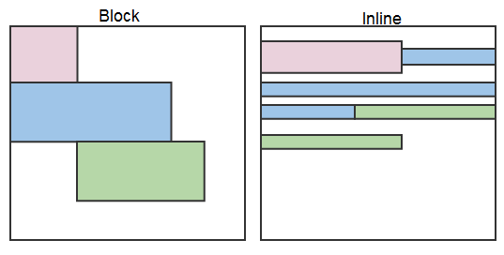

This is showing the HTML4 content model

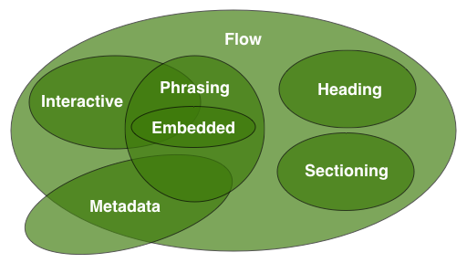

This is showing the HTML5 content model

As you can see from the different diagrams the HTML5 content model is much more complex with more categories to be shown, thus making it more complicated. The HTML5 model is more complicated because now there is more distinct categories with their own content model. The newer model does not have block and inline anymore but instead it subsumes these into its newer model.

Now there is several categories with an element being part of none of them, one of them or several of them. These being metadata content, flow content, sectioning content, heading content, phrasing content, embedded content and interactive content. So from the examples as just mentioned the elements are not exclusive to one type and may belong to more than one category. So overall then the HTML 5 model is more complicated because there is new elements and features that are being added and the inline and block content model was too simple, so that’s why the more complicated HTML5 model was introduced.